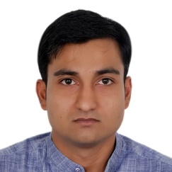

GOPAL GOYAL
BUSINESS DEVELOPMENT|PROJECTS| OPERATIONS
Self-oriented professional; offering 7+ years rich and extensive experience in managing different profile and ensuring on time deliverables; targeting assignments with an organization of repute.
er.gopalgoel@gmail.com+91-9971936474

Profile Summary
A skilled professional with a blend of engineering, management & business development; have bachelor of technology in Mechanical Engineering & MBA in Marketing.
Having international business development experience, successfully handled complete portfolio of Business Development viz. RFP,RFQ,EOI,RFI, Market Research, PQ preparation and Bid Submission (Offline & Online). In-depth understanding of different financial terms & conditions, comfortable in dealing with financial aspects of the process.
Skilled in managing different projects i.e. Solar (Developer, EPC & Operation and management), Transmission Line, Telecom Infra operations and maintenance (Passive and Active Infra). Ensuring quality, OPEX Control, Energy cost reduction, People and resource management, efficiently maintained SLA.
An enterprising leader with strong planning, communication, interpersonal, analytical, problem-solving & negotiation skills; proven capability to surpass targets within deadlines & pressure and work with multi-cultural & cross-functional people.

Education

- MBA (Marketing) from Sikkim Manipal University (Distance Education) in 2014 with 69%
- B.Tech. (Mechanical Engineering) from Kurukshetra University (HCTM, Kaithal) in 2010 with 60%

Core Competencies
Pre-sales/ Business Development | Project /Operations Management | Project & Cost Planning/MS Project
SLA Management/ Quality Control | Data Mining/Data Analysis | Revenue Planning & Budgeting
BID Management | Solar Power Projects | Team Leadership & Vendor Management

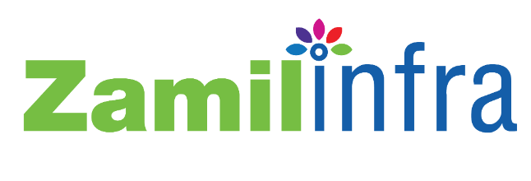
Career Timeline
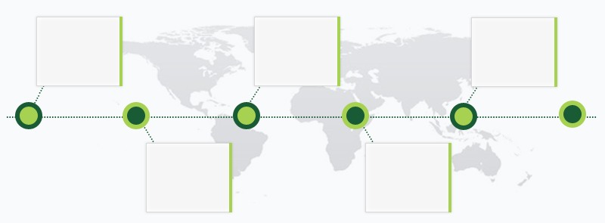
Oct’ 17- Present
Punj Lloyd Ltd.
Manager- Business Development, Gurgaon

Jan’15-Jan’16
Zamil Infra Pvt. Ltd. Manager
Sales & Business
Development
South Africa

Nov’ 16 –Oct’ 17

Punj Lloyd Ltd.
Project Manager, Gurgaon

Jan’14-Jan’15

Zamil Infra Pvt. Ltd. Manager (Operations)

Jun’11 – Jan’14
Zamil Infra Pvt. Ltd.(Assistant Manager)
Nepal
Work Experience Skill Set

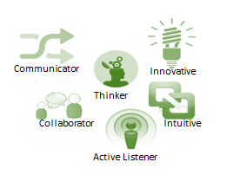
(Nov’16-present) with Punj Lloyd infrastructure limited.
(Jun’11-Feb’16) with Zamil Infra Pvt. Ltd.

Growth Path:
Jun’11-Jun’12 Engineer, Nepal
Jun’12-Jan’13 Power SME (Senior Engineer), Nepal
Jan’13-Jun’14 Assistant Manager (Operations),Nepal
Jun’14-Jan’15 Manager (Operations), Nepal
Jan’15-Jan’16 Manager (Sales & Business Development),
Johannesburg, South Africa
Nov’16- Oct’17 Project Manager ( 36 MW Solar Power Plant),
Gurgaon, India.
Oct’17- Present Business Development Manager, Gurgoan.
Key Result Areas (Telecom):

- Managed Telecom Infra Structure operations and maintenance (Passive and Active Infra), Telecom up-gradation/swapping, installation, Telecom Implementation, repair and rectification of all passive & active infra equipment
- Strategized and implemented project plans within preset budgets and deadlines and worked with development teams and specialists to ensure the right tools are available for content collection
- Maintained Infra up time = 99.99%, provided SLA Management, Corrective and Preventive Maintenance and ensured people & resource management
- Efficiently maintained:
- Cell site uptime and alarm automation as per defined SLA
- Extensive site quality by implementing plan of weekly site health check-up/audits and site key management, site security & safety to identifying gaps and to timely rectify all punch points in a cost-effective manner
- Performed manpower mobilization as per requirements and provided budgeting, AOP, Cost Leadership, Analysis & Optimization support.
- Conducted periodic performance reviews with customer, to analyze organizational performance and to accordingly initiate improvement actions wherever required; reconciled OPEX claims with customers & ensured OPEX and reduction in CAPEX
- Ensured Rate & BOQ finalization with vendors, regularly followed up with SCM regarding timely material delivery and performed a weekly & monthly material requirement forecast as per set targets
- Attended weekly/monthly meeting with customer for various site issues and closed them in the defined time line
- Steered teams to ensure 100% alarm integration with NOC and site automation
- Ensured timely rectification of faulty equipment repairs like DG, PIU,PMS, SMPS, BB, ACDB, EB, DC FCU, Air Conditioner PDH (S400,S500) BTS,RSU, Microwave, ODU, Feeder Cable, OFC cable and other equipment as per SLA
- Ensured process improvement by implementing different strategies like SWOT Analysis , 5-Why Analysis, Fish bone Analysis & Brain Storming and in turn enhanced output quality and customer satisfaction

Key Result Areas (Solar):

- Completed total 36 Mw solar projects. (36 Mw in Uttarakhand).
- Worked with land acquisition teams for CLU (Compatible land Use).
- Done projects planning (MS Project), purchase, vendor management, quality control, civil & electrical engineering review, vendors billing & payments and timely delivery of projects.
- Completed MNRE approvals, DISCOM & UREDA approvals for plant execution.
- Handled Solar Power plant operations and maintenance, tracked generation losses and down time for better generation.
- Installed Transmission line of total 20 Km in Uttarakhand, Including liasoning with locals, Material Inspection from DISCOM, Gantry and panel installation.

Key Result Areas (Business Development):

- Developed sale strategies to build consumer preference and to successfully drive volumes, conducted competitor analysis by keeping updated with market trends and evolved market segmentation & penetration strategies to achieve targets set by the organization.
- Market search for opportunities, upcoming projects identification etc.
- Preparation of PQ as per RFQ, Bid Submission (Online & Offline), Pre-Bid Meetings, RFI, EOI, POA, EMD/BG etc.
- converted RFP/RFQ into PO, managed bidding & responded to RFPs
- Performed country specific market research to identify opportunities.
- Port Folios handled so far:- Telecom, Solar, Roads and Transportation, Power (Sub- Stations, FGD, Transmission Line, BOP, STG, Etc.), Aviation, Buildings, Railway , OHE (Railways).

Notable Accomplishment Across Tenure International Exposure
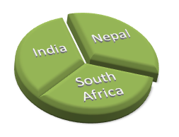
- Rewarded with a number of awards like:
- Young Talent for the year 2013 for best account execution and
customer relations
- Best Performer in 2012
- Added into the coveted Leadership Team of 25 leaders
- Proficiently executed duties in India, Nepal & South Africa
- Successfully monitored and contacted potential customers for sales in offshore
Territories of Nigeria, Thailand, Bangladesh, Kenya, UAE & Australia from India
- Recognized for enhancing the quality & time delivery of projects and in turn
Ensuring increase in business and revenue.
- Efficiently managed & Completed EPC of 3 X 12 MW solar power projects.

Offshore Accounts Handled
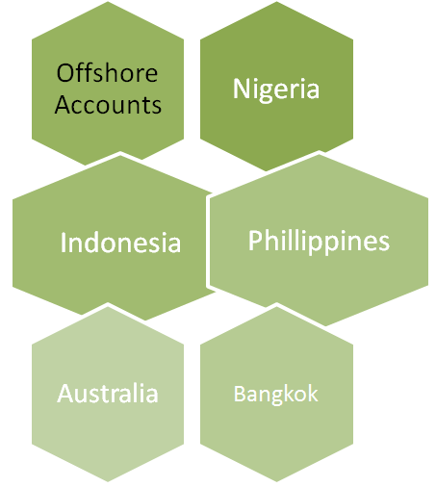
- Acknowledged for improving timelines of daily updates on National & International
projects
- Managed Sales of Telecom Towers, O & M Services, Full Trunkey Service &
Power solutions
- Worked as a part of Pre-sales team (Biding Team) as well as gained strong
understanding of financial & commercial terms while being associated with
different teams
- Appreciated for smoothly managing projects in peak pressure
- Successfully brought order of worth USD 2 million ( Supply Order), USD 1 M
as FTK and services order in 2015-16
- Proficiently managed Services & Supplies for multiple countries and efficiently
responded to RFP of companies like Nokia, Ericsson, Zte, Huawei, MTN ,
Vodacom, Telenor, Axiata, Helios Towers, American Towers, HTN & Etisalat
- Recorded an effective 35% cost reduction by efficiently planning resources and by
saving on service cost paid to vendors; in turn increasing process efficiency
- Acknowledged for successfully spearheading reduction in pilferage & leakage and reduced losses due to inefficiencies in various departments
- Recorded 45% EBITA , by proficiently maintaining managed service business and
strategically optimizing 3 M's of management ( Man,Material &Money)
- Successfully monitored 24 hours sites down & alarms, reviewed NOC reports
(Outage/uptime/fault) and implemented corrective action for ensuring 99.99% infra uptime

Personal Details

Date of Birth: 21st March 1988
Languages Known: English, Hindi.
Address: Global Engineering, Ismailabad , District kurukshetra , Haryana.

